

Assignment 2?

Addison Douglas



October 29, 2022

Everett Community College

axdouglas@students.everettcc.edu

# Description

This assignment asks for the creation of an employee management system. It asks you to create an employee class which has id, name, gender, job title, organization, and birthday of the employee. Then the system needs to be able to add employees, update their information and print out employee information.

# The Code (if more than one question, then specify the question and paste the code of every question)

Copy and paste the code of your questions.

**CALLER CLASS**

/**

*

*/

package cs141.axdouglas;

import java.util.Scanner;

/**

* @author axdouglas

*

*/

/**

* Name:Addison Douglas

* Section: 1

* Program Name: Caller

* Description: This is the class to call the employee class

* It has 2 methods, add employee which takes user input and creates an employee and the printemployee

* class which prints out all the employees in the allArray, an Array containing all the employess that

* have been created

*

*/

public class Caller {

static Employee allArray[] = new Employee[5];

/**

* @param args

*/

public static void main(String[] args) {

// TODO Auto-generated method stub

Scanner userInput = new Scanner(System.in);

System.out.println("~~~~Welcome to the Employee Managment System 1.0~~~~");

Employee Employee1 = addEmployee(userInput);

System.out.println("~~~~~~~~~~~~~~~~~~~~~");

Employee Employee2 = addEmployee(userInput);

System.out.println("~~~~~~~~~~~~~~~~~~~~~");

Employee Employee3 = addEmployee(userInput);

System.out.println("~~~~~~~~~~~~~~~~~~~~~");

allArray[0] = Employee1;

allArray[1] = Employee2;

allArray[2] = Employee3;

printEmployee();

}

public static Employee addEmployee(Scanner userInput) {

boolean test = true;

int organaztionNumber;

Scanner userInput2 = new Scanner(System.in);

String organaztion = "";

System.out.print("Enter employee name: ");

String name = userInput.nextLine();

System.out.print("Enter employee gender: ");

String gender = userInput.nextLine();

System.out.print("Enter employee job title: ");

String jobTitle = userInput.nextLine();

System.out.print("Enter employee birthday, format mm/dd/yy ");

String birthday = userInput.nextLine();

while(test) {

System.out.print("Please choose an organaztion, type 1 for Google 2 for Mircosoft: ");

organaztionNumber = userInput2.nextInt();

if(organaztionNumber == 1){

organaztion = "Google";

break;

}

else if(organaztionNumber == 2) {

organaztion = "Microsoft";

break;

}

}

Employee employee = new Employee(name, gender, jobTitle, organaztion, birthday);

return employee;

}

public static void printEmployee() {

int total = Employee.getTotalEmployee();

System.out.println("Total employee count: " + Employee.getTotalEmployee() + " ");

System.out.print("Total google employee count: " + Employee.getGoogleCount()+ " ");

System.out.print("Total microsoft employee count: " + Employee.getMicrosoftCount()+ " \n");

for(int i = 0; i < total; i++) {

System.out.println(allArray[i]);

}

}

}

**Employee Class**

/**

*

*/

package cs141.axdouglas;

/**

* @author axdouglas

*

*/

/**

* Name:Addison Douglas

* Section: 2

* Program Name: Employee

* Description: This is the employee class, in the construcor it takes in 5 varibles, one for name, gender, jobtitle, organization,

* and birthday of the employee, the id is then randomly generted, and totalEmployee is increased, depending

* on what organizatin the employee is in either microsoftCount or googleCount is inreased, beyond that there are setters

* and getters for the varibles and a toString method to format the output of the employee class.

*

*/

public class Employee {

private int id;

private String name;

private String gender;

private String jobTitle;

private String Organazation;

private String birthday;

static private int microsoftCount;

static private int googleCount;

static private int totalEmployee;

public Employee(String name, String gender, String jobTitle, String organazation, String birthday) {

totalEmployee++;

this.name = name;

this.gender = gender;

this.jobTitle = jobTitle;

this.Organazation = organazation;

this.birthday = birthday;

if(organazation.equalsIgnoreCase("Microsoft")) {

microsoftCount++;

}

else {

googleCount++;

}

id = (int) (Math.random() * 1000000);

}

public String toString() {

return ("ID: " + id + "\n" + "Name: " + name + "\n" + "Gender: " + gender + "\n" + "Job title: " + jobTitle + "\n" + "Organiztion: " + Organazation + "\n" + "Birthday: " + birthday);

}

/**

* @return the totalEmployee

*/

public static int getTotalEmployee() {

return totalEmployee;

}

/**

* @param totalEmployee the totalEmployee to set

*/

public static void setTotalEmployee(int totalEmployee) {

Employee.totalEmployee = totalEmployee;

}

/**

* @return the name

*/

/**

* @return the microsoftCount

*/

public static int getMicrosoftCount() {

return microsoftCount;

}

/**

* @return the googleCount

*/

public static int getGoogleCount() {

return googleCount;

}

public String getName() {

return name;

}

/**

* @param name the name to set

*/

public void setName(String name) {

this.name = name;

}

/**

* @return the gender

*/

public String getGender() {

return gender;

}

/**

* @param gender the gender to set

*/

public void setGender(String gender) {

this.gender = gender;

}

/**

* @return the jobTitle

*/

public String getJobTitle() {

return jobTitle;

}

/**

* @param jobTitle the jobTitle to set

*/

public void setJobTitle(String jobTitle) {

this.jobTitle = jobTitle;

}

/**

* @return the organazation

*/

public String getOrganazation() {

return Organazation;

}

/**

* @param organazation the organazation to set

*/

public void setOrganazation(String organazation) {

Organazation = organazation;

}

}

# The output

Screenshots of your runs.

3 screenshots of 3 scenarios you tried in your program.

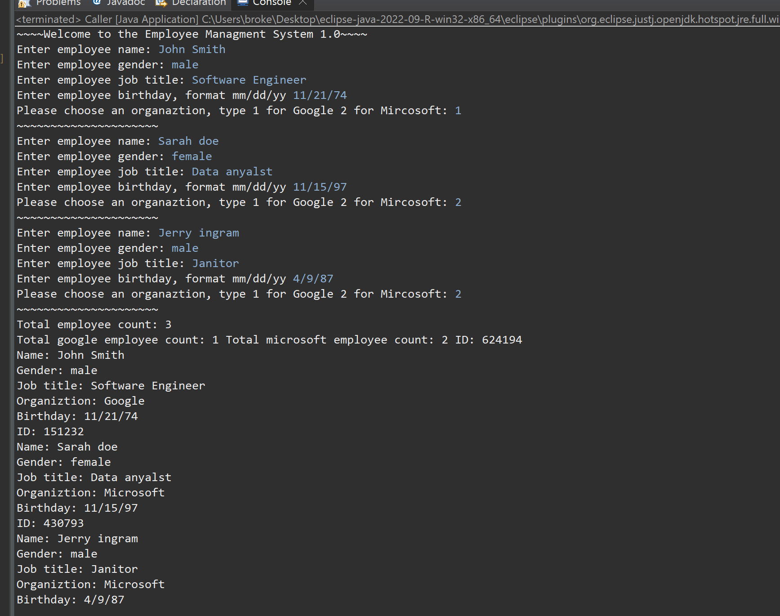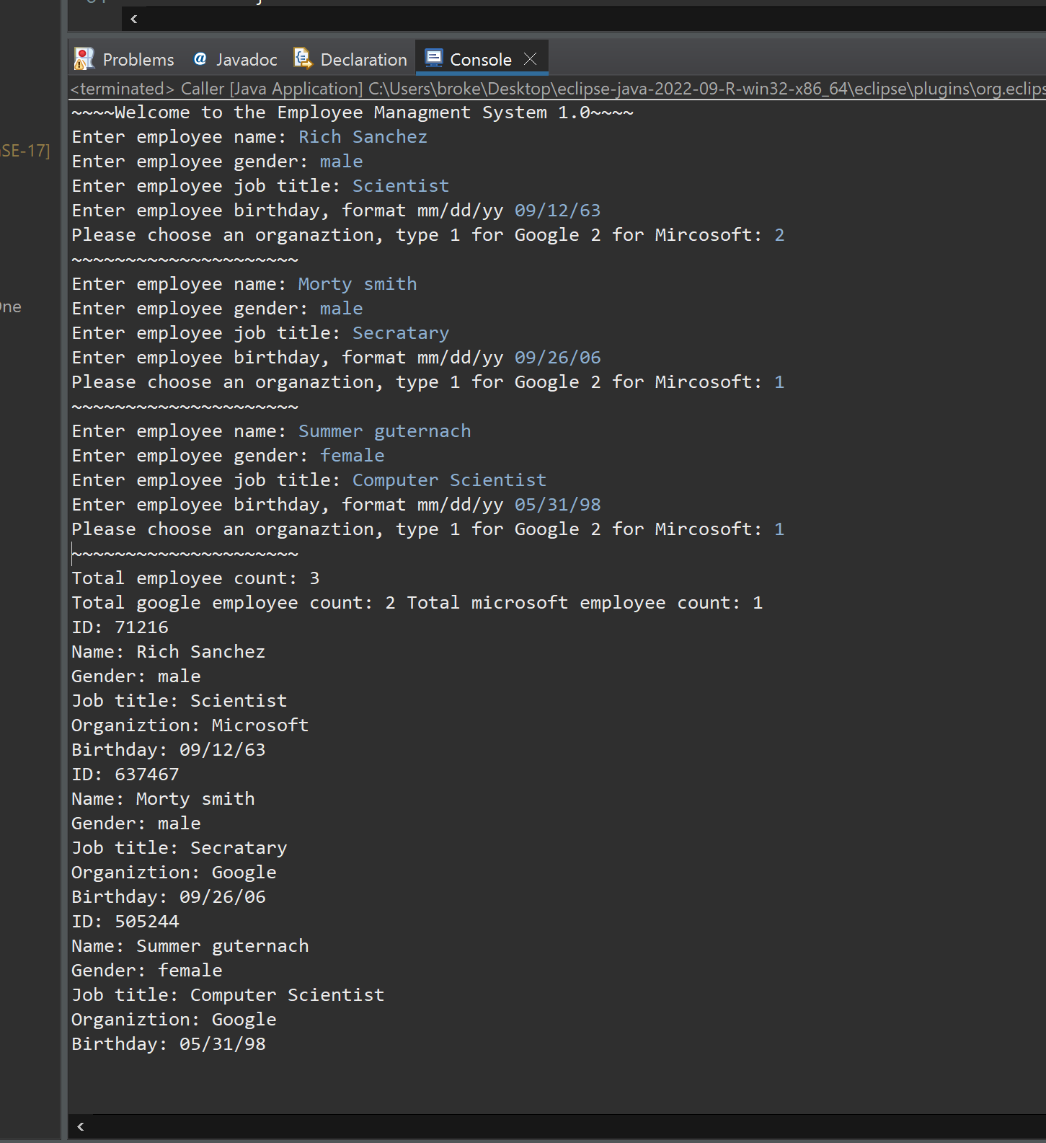

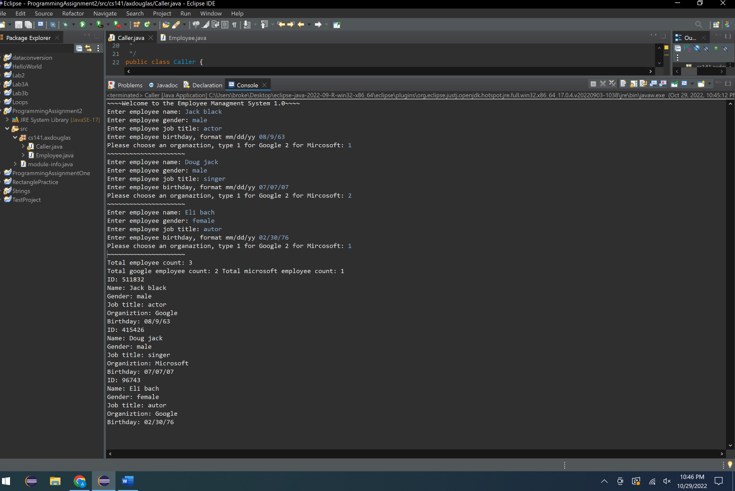

# Comments/Notes (Extra Credit)

The comments or the notes section is if you wanted extra credit. This could be struggles you have come over while doing your program, or additions you wanted to highlight so I notice while grading…

At first it was difficult to decide how the class would be created, needing user input, I ended up creating a method in the main class to be called when an employee is created. Then it was figuring out that I could create an array of objects, but printing it out was a struggle until I discovered the toString method which allowed me to format out for the employee class.